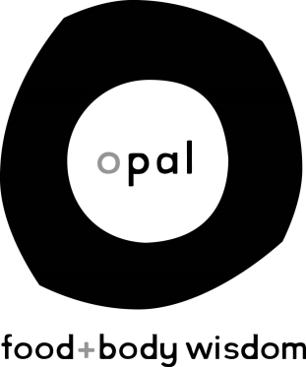

Opal: Food+Body Wisdom, an eating disorder treatment facility in the University District of Seattle, Washington, offers intensive day treatment as well as outpatient services. We are looking for skilled individuals who want to join our team to provide quality treatment and work along side a passionate and caring staff.

Job Title: Full-Time Milieu Therapist

Responsibilities:
-Provide a safe, supportive, and encouraging environment for the partial hospitalization program clients.
-Provide direct assistance throughout day by means of:
  - eating with clients at meals and snack times
  - monitoring bathroom use for eating disordered behaviors
  - socializing and observing clients during breaks and transitions in programming
-Collaborate with other members of a dynamic, multi-disciplinary treatment team
-Help with training new milieu staff
-Assist staff therapists and/or dietitians with tasks related to client care
-Co-facilitate various therapy groups
-Maintain clinical documentation and other administrative tasks required for competent care

Requirements:
-An Associates degree, bachelor’s degree, or working towards bachelor’s degree with emphasis in the study of Psychology; Masters degree in psychology, counseling or social work is preferred
-Live, behave and talk in a way that reflects a non-diet, non-weight biased relationship with food and body.
-Exhibit a high degree of confidentiality and personal boundary setting
-Experience and/or understanding of eating disorders is highly desired; experience in other mental health field beneficial
-Openness to learn new skills and take risks
-Able to address conflict with directness and compassion
-Comfortable with basics of nutrition, ie meal planning, basic cooking skills, grocery shopping, etc.

Hours:
The hours will vary depending on our need at the time of applications. All hours will be between 7:30am-6:30pm Monday-Friday. Full time is 32-40 hour weekly

Compensation:
Commensurate to experience. Full time positions are fully benefited.

Interested?
Email Julie Church at julie@opalfoodandbody.com

Opal: Food+Body Wisdom : : www.opalfoodandbody.com : : 1100 NE 45th Street, Ste 600, Seattle, WA 98105

