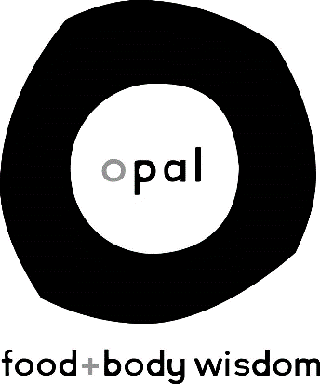

Opal: Food+Body Wisdom, a locally and clinician owned, eating disorder treatment facility in the University District of Seattle, Washington, offering Partial Hospitalization, Intensive Outpatient and traditional outpatient services. We are looking for skilled individuals who want to join our team to provide quality treatment and work alongside a passionate and caring staff.

Job Title: Primary Therapist
Opal: Food+Body Wisdom, an eating disorder treatment clinic, is looking for a Psychiatric Nurse Practitioner that would like to offer mental health therapy and medication management to individuals struggling with eating disorders. Opportunities to be a part of Opal's Exercise + Sport program are available.

Responsibilities:
o Provide individual and group therapy for our Partial Hospitalization Program, Intensive Outpatient Program and Outpatient Program clients.
o Provide medication management for clients, as needed
o Collaborate with other members of a multi-disciplinary treatment team
o Maintain clinical documentation and other administrative tasks required for competent care
o If an applicant is fitting to be a part of Opal's Exercise+Sport team additional responsibilities would include: individual therapy with clients with athletic identities and/or sports backgrounds, facilitating specific groups related to sports, exercise and movement, 1:1 exercise experiential sessions, and participating in occasional community outreach events
o Leadership opportunities also available for applicants with interest/experience in management.

Requirements:
o Must be certified to practice as an Advanced Registered Nurse Practitioner in Washington state with specific psychiatric discipline
o System approach desired – strong team work skills needed
o Experience working with clients with eating disorder is highly desired
o Alignment with Opal values – view our website to learn more about our approach
o Live, behave and talk in a way that reflects a non-diet, anti-oppressive, non-weight biased relationship with food and body
o Current credentialing with insurance panels is highly desired
o If desiring to be a part of the Exercise + Sport team we are looking for someone with a strong, personal athlete identity, or specific experience with athletic population (ie coaching, personal training, sports-specific academic coursework). In addition, a working knowledge of compulsive and avoidant exercise behaviors is desired.

Hours:
32-40 hours/week

Compensation:
Commensurate to experience. Benefits package includes: Medical/Dental/Vision insurance, PTO, paid holidays, retirement account with employer matching, paid continuing education.

Interested?
Email: careers@opalfoodandbody.com

