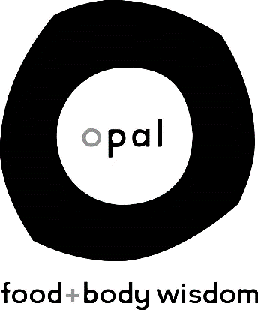

Opal: Food+Body Wisdom, a locally and clinician owned, eating disorder treatment facility in the University District of Seattle, Washington, offering Partial Hospitalization, Intensive Outpatient and traditional outpatient services. We are looking for skilled individuals who want to join our team to provide quality treatment and work alongside a passionate and caring staff.

Job Title: Primary Therapist- Sport Specific Focus

We are seeking a provider with interest and experience in working with eating disorders in athletes and active individuals as a part of the Exercise+Sport team at Opal

Responsibilities:
- Provide individual and group therapy for our Partial Hospitalization Program, Intensive Outpatient Program and Outpatient Program clients, including those with athletic identities and/or sports backgrounds
- Facilitate specific groups related to sports, exercise and movement
- Collaborate with other members of a multi-disciplinary treatment team
- Participate in Exercise+Sport team which involves community outreach opportunities
- Maintain clinical documentation and other administrative tasks required for competent care

Requirements:
- Must be a licensed therapist in the state of Washington as a LMHC, LMFT, LICSW, LASW, ARNP, or a Licensed Psychologist
- Must have either: 1) strong, personal athlete identity, or 2) specific experience with athletic population (ie coaching, personal training, sports-specific academic coursework)
- System approach desired – strong team work skills needed
- Alignment with Opal values – view our website to learn more about our approach
- Experience working with eating disorder patients is highly desired, including a working knowledge of compulsive exercise
- Live, behave and talk in a way that reflects a non-diet, anti-oppression, non-weight biased relationship with food and body
- Current credentialing with insurance panels is highly desired

Hours:
32-40 hours/week

Compensation:
Commensurate to experience. Benefits package includes: Medical/Dental/Vision insurance, PTO, paid holidays, retirement account with employer matching, paid continuing education

Interested?
Email: careers@opalfoodandbody.com

